IFG Adventure 2nd Year

Term Three - Week Seven: Elderz Community
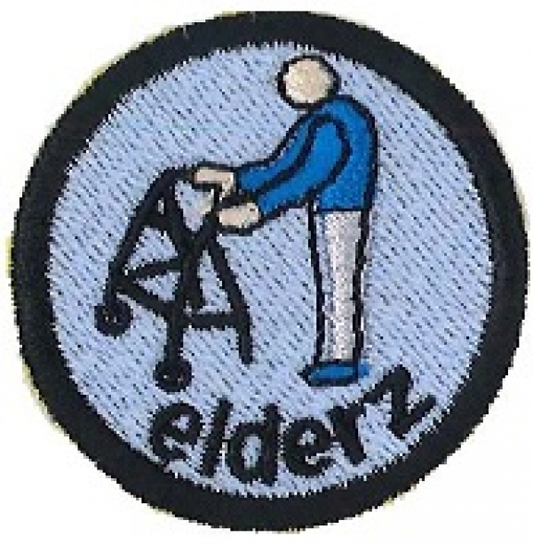
Aim:
- To teach the girls about the lives of older people in our communities

Objectives:
- To give the girls some understanding about what happens to us when we get older
- To teach the girls how getting older can limit your activities..

Preparation:
- Organise a speaker and/or a panel of three elderly people..
- Arrange for someone to thank the speaker/panel and present with small gift(s) at the end of the discussion time.
- Newspapers and scissors for devotions.

Pre SetUp:
Ensure speaker/panel understands the ages of the girls and be able to talk about being Senior Citizens and what this means to them.

SetUp:
This is your usual formal start to the evening programme; girls will assemble at the Home Zone for marking the roll etc.

Devotion:
Paper Trees
Object: A paper tree. To make a paper tree, lay about six sheets of newspaper lengthwise, overlapping them almost halfway. Roll the sheets from the short end. During the presentation, make three or four cuts, about three inches deep, from the top; bend back. Holding the bottom of the tube, place fingers in the top of the tube and pull gently.
Lesson: The Christian life is one of living, growing, changing, becoming fuller.
Scripture: "But continue to grow in the grace and knowledge of our Lord and Savior Jesus Christ" (II Peter 3:18).

Outline
Introduce object: Do you think I can make a paper tree out of this roll of newspapers?
1. Even though we don't usually think of it as such, our faith is living.
2. Just as this paper tree appears to be growing, so our faith should be growing.
3. As the tree is changing, becoming fuller and taller, so our Christian faith should be increasing in depth, knowledge, mercy, and goodwill toward others.
Conclusion: How well is your faith? Is it growing?

Story
Do you think I can make a paper tree out of this roll of newspapers? I'll make a few cuts here and there. Now watch me pull this paper out. Of course, this isn't a living tree, but we do have something that is living, even though we don't usually think of it as such. That is our faith. It is living because it is something that should be changing, growing, reaching out to others, and becoming bigger.
This paper tree appears to be growing as I pull the paper up and out. In fact, I can stretch it to quite a height if I am careful. Just how much can our faith grow? There is no end. It should always be growing, learning, and searching.
The paper tree becomes fuller as I expand it. I started with four branches and now must have more than a dozen. More and more emerge as I expand it. So, too, our Christian life becomes fuller, richer, more filled with knowledge, love, mercy, and goodwill toward others.
Faith is not something that comes in a neat little package that stays the same. It is living, growing, changing, and becoming fuller and richer. How well is your faith? Is it growing?
Prayer

Teaching session/Activities
Use Speaker and or panel to introduce the session on “Senior Citizens” and have someone thank these people when they have finished.

Activities:
The activities will be team activities giving the girls an opportunity to try various activities with the restrictions that some of the elderly have to put up with in their daily lives.
Equipment:
- Blindfolds or eye patches.
- Something suitable to use as a walking stick.
- Old pantyhose or equivalent
- Gloves with fingers sewn together
- Potato peelers

Divide the girls in groups and have them move round the groups in a given time period
The group activities would be:
- Peeling potatoes with the gloves on (Arthritis)
- Walking up and down room, also to go up and down some steps using a walking stick with pantyhose tied around their ankles to give them limited size in steps and having to use a walking stick.
- Try to find things (like a treasure hunt) while wearing a blindfold or an eye patch and try to fill a cup with water (Partial blindness or Cataracts)

Notices & home time:

Hand out the notice you have written explaining that the girls will be visiting a retirement village for next week.


IFG Adventure
Term Two – Week Eight Elderz Community
Objective:
- To show the girls how we can care for the Elderly as their bodies and minds begin to deteriorate

Preparation:
- Ensure all arrangements are made with the retirement village to see facilities and meet some residents
- Ensure you have made necessary transport arrangements.
- Complete the forms required when you are away from your usual meeting place.

SetUp:
Commence the formal part of the evening with roll call etc.

Devotions:
Elderly people have learnt over the years that they need to be patient and things will work out for them in the end. God wants us to be patient and he will lead us the way we are supposed to go.

Be Patient
Object: A heavy stack of books placed on one end of a piece of paper large enough so that, when the paper is pulled slowly from the other end, the stack of books will move.
Lesson: God desires us to learn patience.
Text: "Be patient and wait for the LORD to act..." (Ps. 37:7 a).
Outline
Introduce object: How many of you think I can move this stack of books without touching it?
1. Pull the paper quickly—the books don't move.
2. Pull the paper slowly and patiently—the books move.
Conclusion: Patience means trusting in God’s timing not our own.

Story
How many of you think I can move this stack of books without touching it? Let's see. That sounds pretty tough. The books are on this piece of paper—I'll try to move them by pulling on the paper. (Yank the paper from under the books.)
That didn't work. I must have done something wrong. (Replace the paper.) I guess I need to have more patience. What is patience? It is waiting for what God has planned for you. Sometimes it is difficult to wait—for example, if you wait for ice cubes to melt so you can have a drink when you are thirsty. Often when we want something, we want it now? Sometimes patience means enduring something unpleasant, without complaining, until we get what we want or something better. Sometimes patience means doing things slowly, carefully, deliberately—thinking, planning, and considering God's way.
Slowly and deliberately. I'll try pulling this paper carefully. Yes, when I pull slowly, the books stay on the paper and I can move them without touching them. Often, everybody has to wait for something important in her life. It could be recovering from an illness or accident. It could be waiting for a party or some special event. It is not easy to wait, but if you practice having patience, waiting gets easier. Remind yourself that everything will come in God's own time and the waiting will become less troublesome. Direct your energy toward something more useful than complaining about the waiting.
Patience means trusting in God’s timing not our own.

Activity Session:
Visit to retirement Village.
You may like to organise something for the girls to take with them e.g flowers or some baking.

Coach’s Tip:
Complete roll call and take Master Roll with you.

Notices & home time:
End the evening with a prayer

IFG Adventure
Term Two – Week Nine Elderz Community

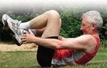
Objective:
- To learn about the wisdom the elderly can share with us

Preparation:
- Organise venue to have equipment for active elderly sports eg croquet, bowls, Tai Chai, and sit exercises.
- Organise a group of active senior citizens to compete with the girls.
- Arrange for someone to thank the senior citizens for joining them on the meeting night.

SetUp:
Commence the formal part of the evening with roll call etc.

Devotions:
Elderly people have learnt many things over the years and have had good and bad experiences. God uses them to help us by sharing their wisdom and experiences that will enable us to be better people.
The Prints We Leave Behind
Object: A drawing or a picture of a fingerprint or an object that has been dusted for fingerprints.
Lesson: We influence the lives we touch.
Text: ". . . and you will be witnesses for me in Jerusalem, in all of Judea and Samaria, and to the ends of the earth" (Acts 1:8).
Outline
Introduce object: Do you know that whatever you touch with your fingers is marked by an invisible print?
1. Our lives touch other people's lives daily.
2. Our touch leaves an invisible mark on people's lives.
3. This mark influences other people. It can be a good witness for what God means in our lives.
Conclusion: The love of Jesus shines in and through what we do—when we touch, when we talk, when we help—and leave a mark of love.
Do you know that whatever you touch with your fingers is marked by an invisible print? The print looks something like this. Each print is just different enough for a forensic scientist to tell if you have touched an object. Usually we cannot see the print, but it can be dusted with a special powder to make it visible. Sometimes a thief is caught because his fingerprints have been found at the scene of a crime.
Do you know that your life touches other people's lives daily and leaves an invisible print? When you speak to someone, you touch her life. You can make people happy with a cheerful word or sad with unkind words. You can bring help or comfort to people or you can make them unhappy by a thoughtless word or action. Even when we are not thinking about it, our words and actions influence other people's lives.
The mark you leave on people's lives is invisible because that mark is on their thoughts and feelings. Sometimes the mark is made visible by their actions or words. You can be "caught" doing something helpful or harmful. Sometimes it is not until years later that we find out what an influence we have had on a person's life.
This invisible influence on a person can change her life. You can leave your mark by telling people about what God means in your life. You can let them know Jesus loves them. Your words and actions can be a witness to what loving Jesus means. You can let them know how Jesus can help them.
The love of Jesus shines in and through what we do— when we touch, when we talk, when we help—and leave a mark of love.
Prayer:

Activity Session:
Mix active senior citizens into groups with the girls and just have fun being active and trying everything that is available at the venue.
Have someone thank the seniors for joining them.

Notices & home time:
End the evening with a prayer

Resources:
There is heaps of information on Elderly Care on the internet.
Some sites you may wish to visit are:
Presbyterian Support Services
Of Course You Can Use a Computer
A Guide to Living Life to the Full in Your Retirement
Activity Needn't End With Retirement
Your Life is in Your Hands
There's Help Available to Modify Your Home

